For various reasons, I continuously see people send their birth certificates to be authenticated without an affidavit of ownership.

Think of it this way. If your birth certificate is a negotiable instrument because it represents the existence of your body as collateral to a security interest, and someone has it in their hands, can’t they claim ownership of it before you do? (This is also why you add a photo on the affidavit).

The blind who is leading the blind isn’t always intentionally mischievous. Sometimes it’s just pure ignorance. And it has been said that many have perished because of it.

WHAT IS AN AFFIDAVIT OF OWNERSHIP?

An affidavit of ownership is a legal document in which a person swears under oath, to the truth of the ownership of a particular item, property, or asset.

This document serves as a written declaration of ownership, and it is usually used to prove ownership in a court of law or to establish clear title to a property.

The affidavit of ownership typically contains details about the item or property in question, as well as the affiant's personal information and a statement of the affiant's belief that they are the rightful owner of the item or property.

An affidavit of ownership typically includes information such as the name of the owner, a description of the property, and any relevant details regarding the transfer of ownership.

The affiant, or person making the affidavit, must sign the document in front of a notary public, who will then witness and verify the signature.

In some cases, an affidavit of ownership may be required by a government agency, financial institution, or other organization to establish ownership or transfer ownership of a property.

WHY ADD A PHOTO TO IT?

Typically, an Affidavit of Ownership is a text-only document that is used to make a statement under oath or affirmation, and it does not typically include any visual elements such as photos or images.

However, depending on the specific purpose for which the Affidavit of Ownership is being used, it may be acceptable or even necessary to include a photo or other supporting documents. For example, if the birth certificate is being used for identification purposes, it may be helpful to include a copy of a photo ID or other identifying documents.

Make sure that the photo is clear and high-quality, and that it accurately represents your identity.

Here's an example template for an Affidavit of Ownership that can be used to verify ownership of a birth certificate:

AFFIDAVIT OF OWNERSHIP

I, [Name of Affiant], of legal age, hereby declare under penalty of perjury as follows:

- I am the legal owner of the birth certificate of [Name of Child], which was issued by [Name of Issuing Authority] on [Date of Issuance].

- I am the [Relationship to Child], and as such, I have lawful possession and control over the birth certificate.

- The information contained in the birth certificate is true and accurate to the best of my knowledge and belief.

- I have not sold, transferred, or otherwise conveyed ownership or possession of the birth certificate to any other person or entity.

- The birth certificate has not been stolen, lost, or destroyed.

- I am executing this Affidavit of Ownership to establish my ownership and lawful possession of the birth certificate, and to authorize its use for identification purposes when necessary.

I understand that the statements contained in this Affidavit of Ownership are made under penalty of perjury and that any false or misleading statements may result in criminal prosecution.
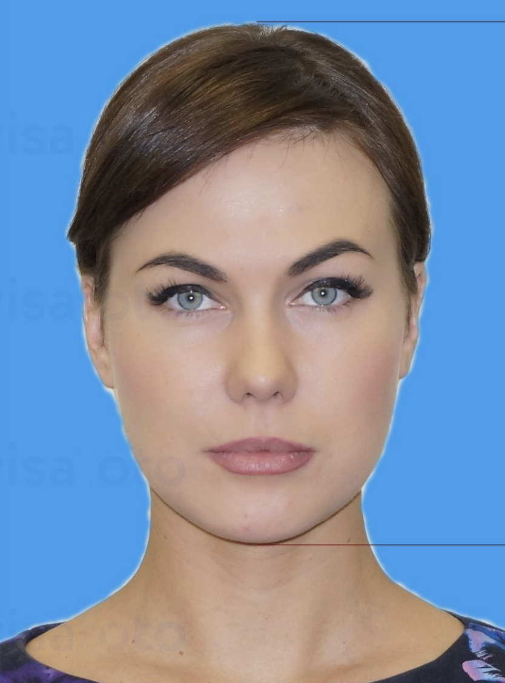
[Print Name Here]

[Sign in blue Here]

(Add red thumbprint on top of signature)

[Date Here]
Date of Execution

[Sworn Before Here]
Sworn Before: [Name of Notary Public]
Notary Public, [State of Commission]
My Commission Expires [Expiration Date of Commission]
See the Current Version of an Affidavit of Ownership of an adult Birth Certificate.

REMEMBER THESE 7 IMPORTANT STEPS:

- Make an editable copy on your computer or your Google Drive account.

- To replace the image, click on it and click on “replace image.” Use the same format, size, and standards for American passport photos. Take it with good lighting and white background. Edit to remove any shadows if possible.

- Everything in Red should be replaced with black bold digital ink, and you should remove the [brackets] wherever applicable.

- Remove the entire line where it says ”REMOVE THIS NOTE BEFORE PRINTING BUT REMEMBER TO ADD YOUR THUMBPRINT” and then print the affidavit in color ink. Don’t add your thumbprint until you sign it in front of the notary.

- (In front of the notary) Sign in Blue ink choosing one of these formats depending on how many current legal names you have:
- By: First: Last, BENE (or Beneficiary)
- By: First-Middle: Last, BENE (or Beneficiary)
- By: First-Second: Last-Name, BENE (or Beneficiary) (for people who have 4 names)

- Let the notary add their Notary Seal and sign in Blue with the same pen. If you have a local bank they can notarize it for free. UPS, FedEx, courthouses, and other places will do it for around $5. Ideally, you should get recommendations from friends so that the same notary can notarize your documents moving forward.

- Put your red fingerprint/thumbprint on top of your signature or around the corner of it (you can do it later when you have your inkpad)

Peace.

S1

